SPENDLENS REFINED SYSTEM DESIGN
Production-Ready Architecture, Database Schema, and Core System Flows
This document describes the refined, production-ready system architecture for SpendLens. It includes components for file parsing, machine learning text categorization, anomaly detection, and automated PDF reporting. Each design decisions maps directly to the functional roles of the development team.

1. Original Design Documents & Mockup
Below is the original system design diagram and dashboard mockup extracted from the team specification documents:
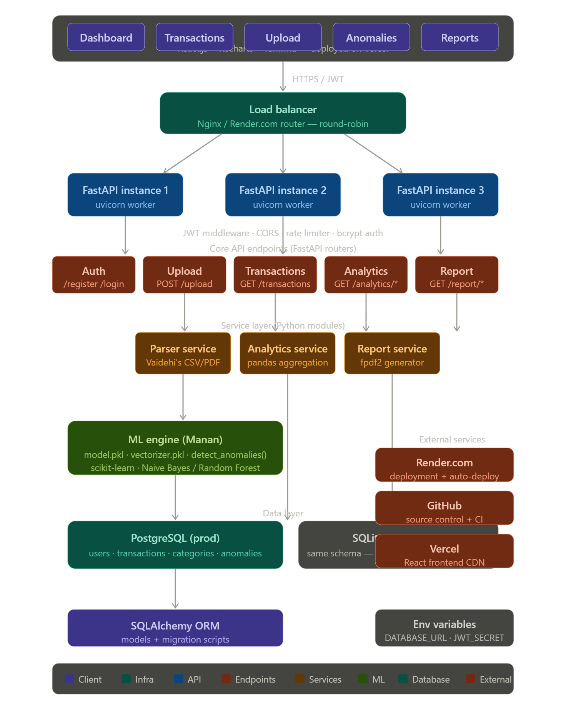
Figure 1.1: Original System Design Overview
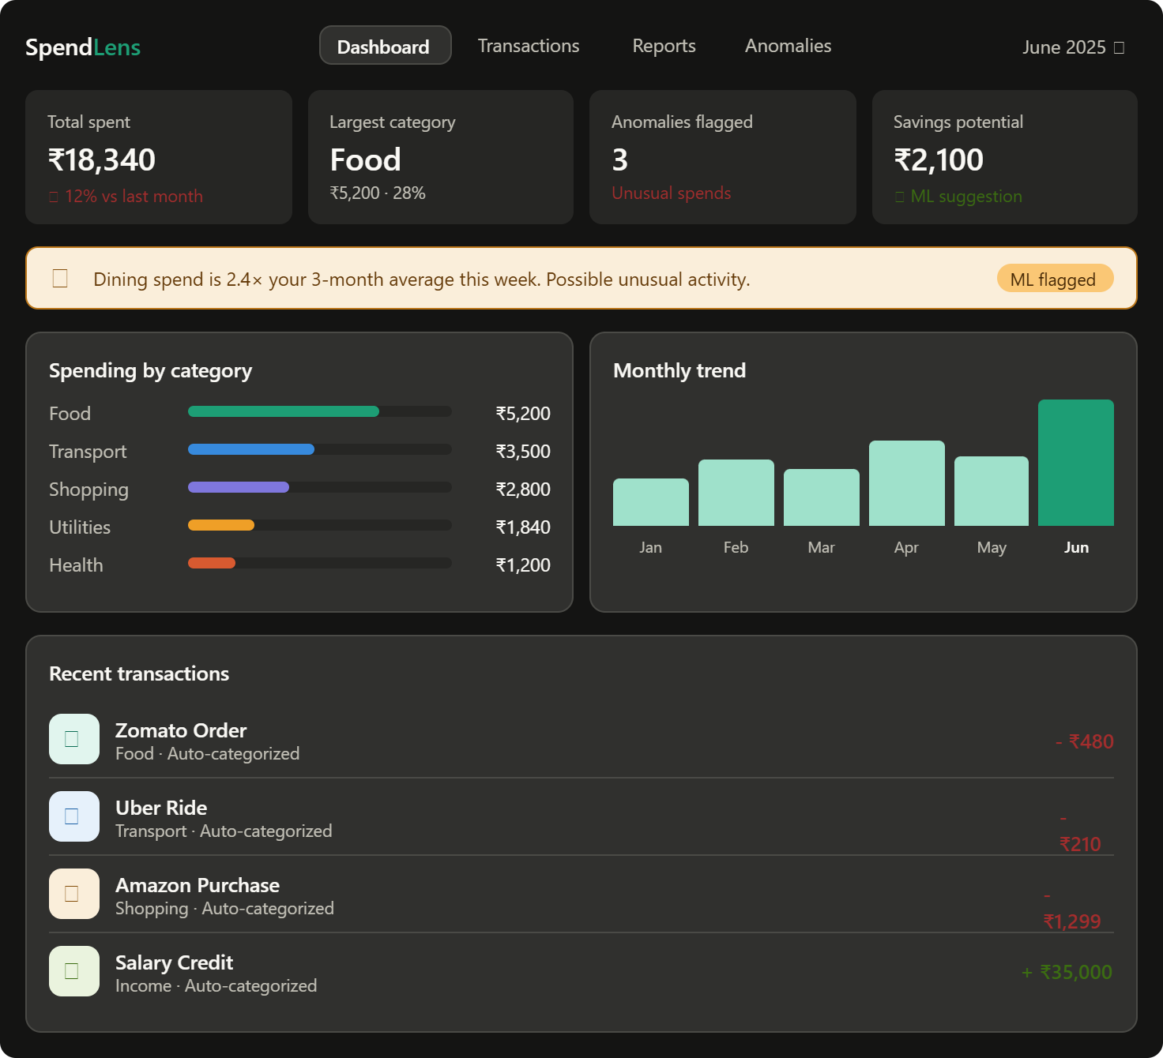
Figure 1.2: Original SpendLens Dashboard Mockup

2. Refined System Architecture Diagram
The refined architecture provides horizontal scaling capability (2-3 workers), Nginx load balancing, SSL/TLS termination, and decoupled application/services/ML layers to maintain high responsiveness.
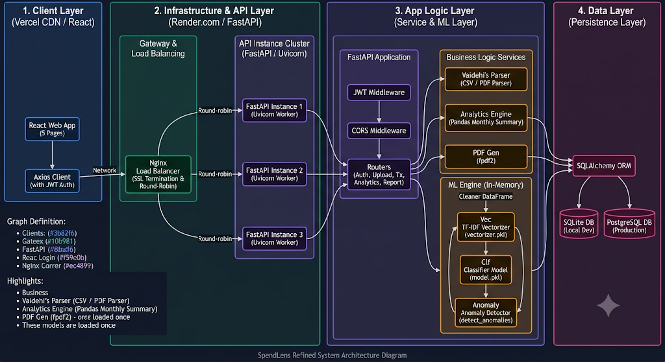

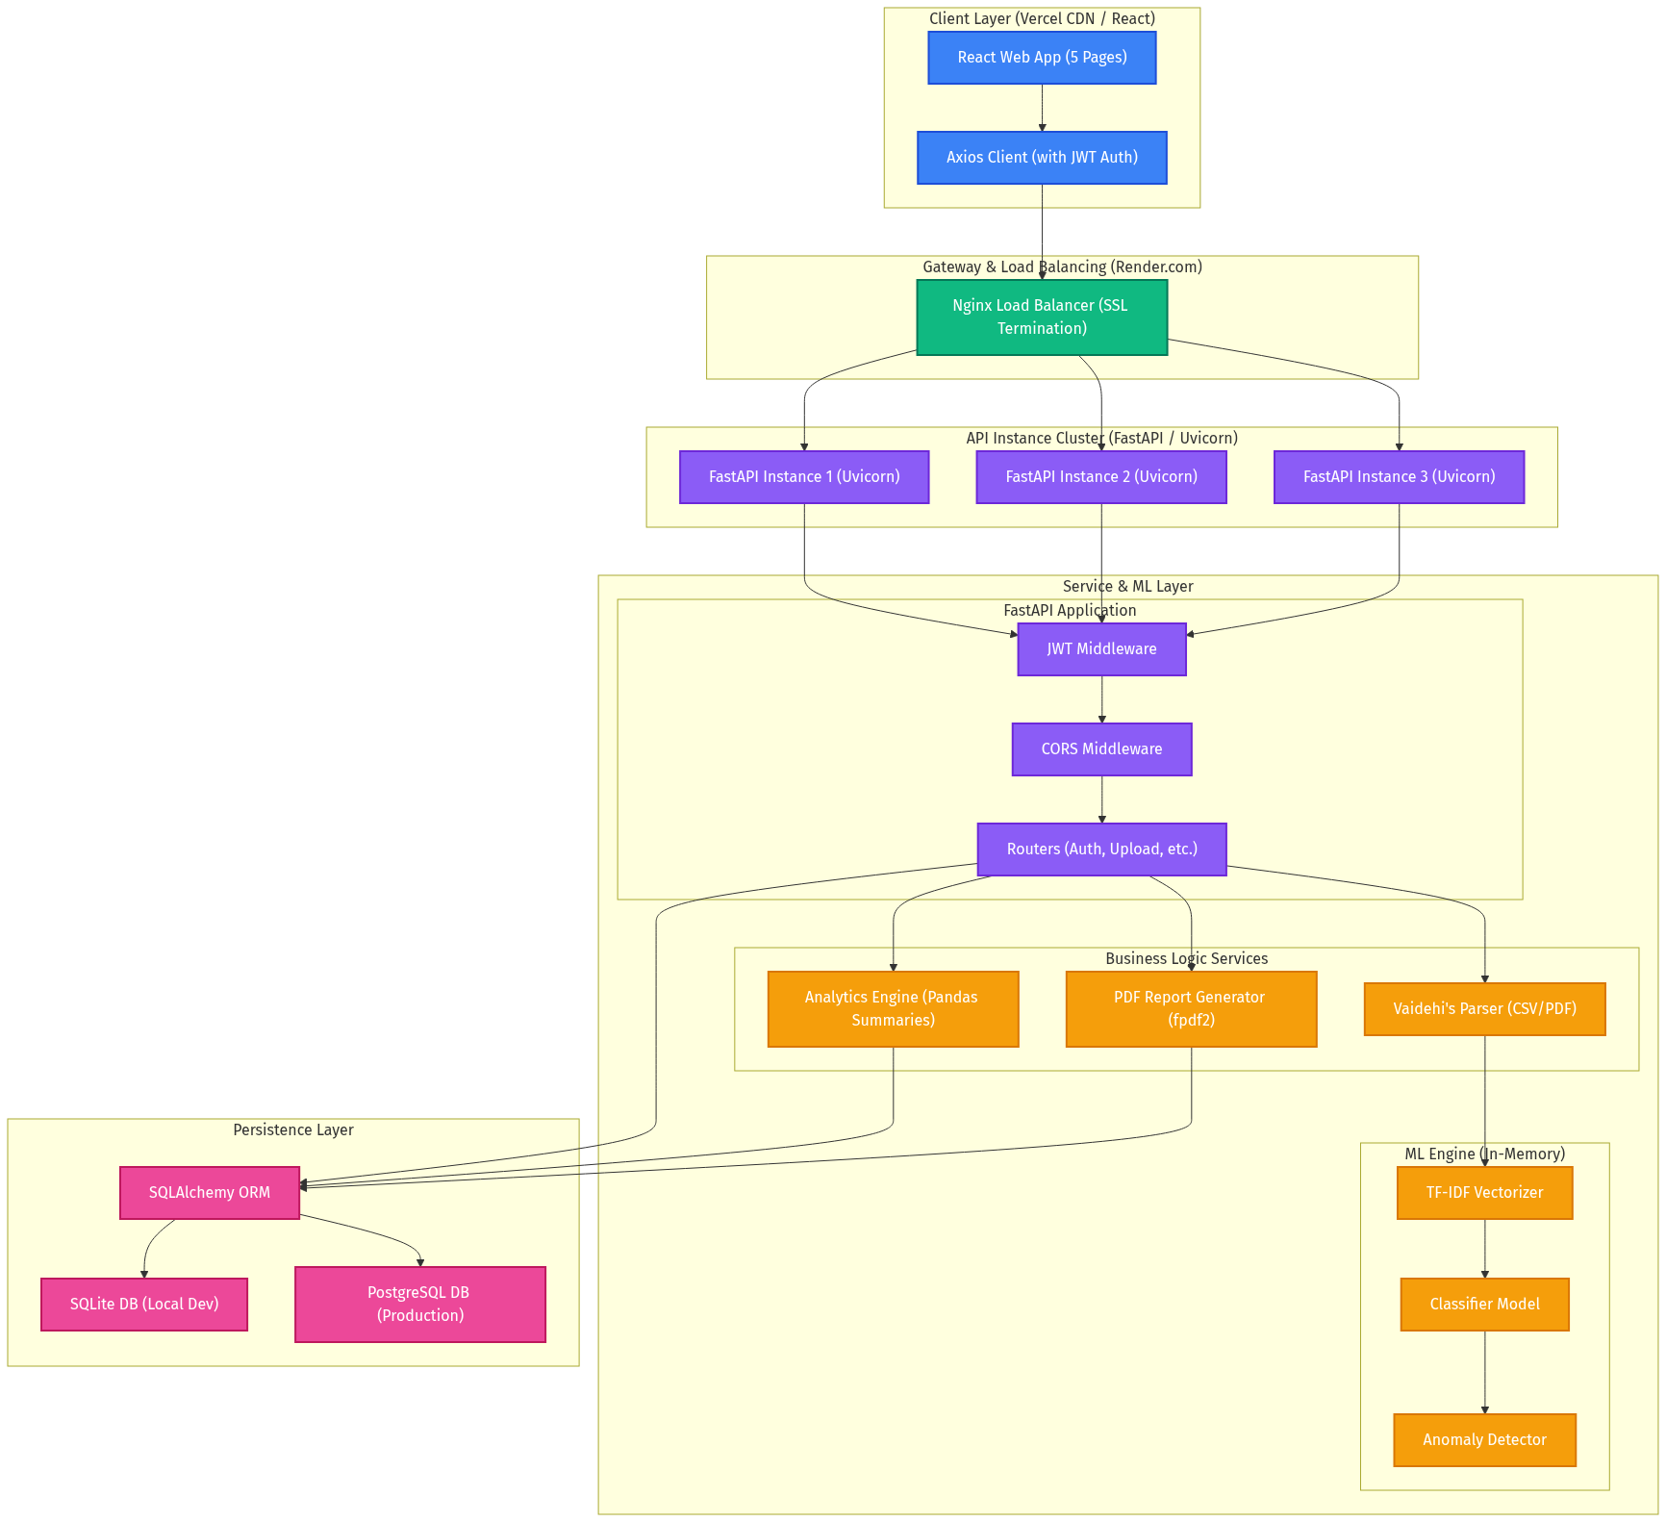
Figure 2.1: Refined SpendLens Multi-Tier Architecture
- Client Layer (Vercel CDN / React): Decouples UI and static assets, utilizing Axios with JWT inside the Authorization header to call internal APIs securely.
- Gateway & Load Balancing (Nginx): Routes requests using a round-robin protocol and terminates SSL, freeing FastAPI instances from handling security overhead.
- FastAPI Instance Cluster: Employs multiple FastAPI instances running as uvicorn workers for high concurrency and failover protection.
- Service & ML Layer: Encapsulates parser modules, analytical helpers, and PDF report generators. The scikit-learn models (model.pkl and vectorizer.pkl) are loaded once at startup using FastAPI lifespan events to prevent CPU overhead.
- Persistence Layer: Utilizes SQLAlchemy ORM to switch database configurations between a local SQLite file (dev) and an external PostgreSQL database (prod) using a DATABASE_URL env var.

3. Bank Statement Processing & ML Sequence
The core functionality of SpendLens relies on parsing statements, categorizing transactions via ML, and detecting anomalies. Below is the detailed sequence flow of the statement upload pipeline:
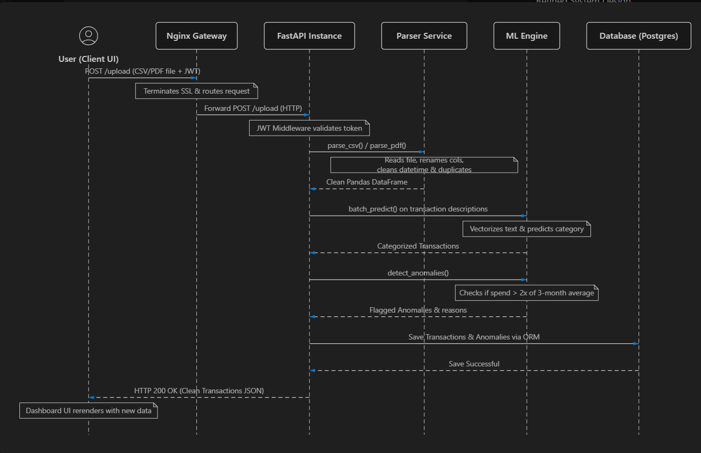
Figure 3.1: Sequence Diagram of CSV/PDF Upload and Processing
1. User uploads the statement file via React Frontend, passing JWT in request headers.
2. Nginx gateway receives HTTPS traffic, terminates SSL, and forwards HTTP traffic to one FastAPI worker.
3. FastAPI middleware verifies the JWT token validity; if valid, routes request to POST /upload.
4. FastAPI calls Vaidehi's parser module (parse_csv / parse_pdf) which reads data using Pandas, standardizes columns (date, description, amount), removes duplicates, and cleans dates.
5. Parser returns a clean Pandas DataFrame of transactions to the endpoint.
6. FastAPI executes a batch predict() call utilizing the in-memory TF-IDF Vectorizer and ML Classifier.
7. FastAPI triggers the detect_anomalies() function to check if the current month's spending in any category is >2x the 3-month average, flagging transaction anomalies.
8. Transactions and flagged anomalies are written to the Postgres database through SQLAlchemy.
9. A JSON response containing the clean, categorized transactions is returned to the client, updating the UI charts.

4. Database Schema (Entity Relationship Diagram)
The relational schema supports user sessions, records categorized transactions, and keeps track of flagged anomalies:
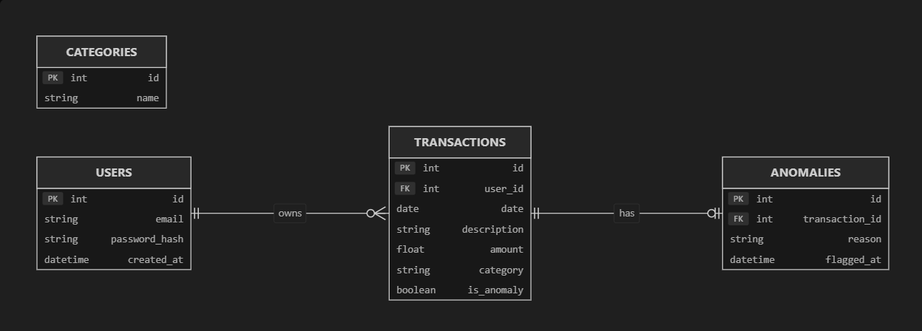
Figure 4.1: Relational Schema Entity Relationship Diagram
- users: id (PK), email, password_hash (bcrypt), created_at
- transactions: id (PK), user_id (FK), date, description, amount, category, is_anomaly
- categories: id (PK), name
- anomalies: id (PK), transaction_id (FK), reason, flagged_at

5. Production Recommendations
• Asynchronous Job Processing: Instead of parsing and predicting synchronously, utilize FastAPI BackgroundTasks or Celery with a Redis message queue. This protects API workers from timeouts during large CSV/PDF statement processing.
• Database Migrations (Alembic): Introduce Alembic to version control the SQL database. This automates schema updates and rollback procedures safely across staging and production.
• ML Lifecycle Management: Incorporate ML model versioning (e.g. tracking vectorizer.pkl and model.pkl version codes) to roll back or test newer classification models without redeploying backend logic.
• Rate Limiting & Security: Employ slowapi for API rate limiting on authentication and upload endpoints, store environment configurations securely in a .env file, and establish Nginx DDoS firewall protections.

